CS-390
Fundamental Programming Practices

Final Exam

Name: ___________________ ID: ________________

I (16) | II  (16) |  |  | III  (24) |  | SCI  (3)

Part I. Multiple Choice & True/False Questions. (2 points each) For multiple choice, circle the best answer; circle only one answer in each problem. For True/False, mark it either ‘T’ or ‘F’.

- Which of the following statements is true?
  - Use ArrayList when a lot of insertions and removals are needed.
  - There is no need to shift elements when we remove elements from ArrayList.
  - LinkedList implements RandomAccess.
  - Resizing is not necessary for a LinkedList when a lot of insertions are done.
- Suppose a list mylist contains objects that do not have a natural ordering. (Note: Integers and Strings have a natural ordering but Persons and Employees do not.) Assume the following line of code compiles and runs without error:
Collections.sort(mylist)
Which of the following statements is not necessarily true?
  - The type of mylist is a subtype of List
  - The type of mylist is a subtype of Iterable
  - The type of mylist is a subtype of Comparable
  - The type of each element of mylist is a subtype of Comparable

- Suppose you create your own kind of List class, based on an array, in which you plan to store Strings in sorted order. Which Java interface(s) must you implement in order to be sure that the method call
Collections.binarySearch(<your list>, <your string>)
will run properly and use the fast binary search algorithm on your List in searching for your test String? Circle the best answer.

- The List interface is enough
- The Iterable interface is enough
- Both the List interface and the RandomAccess interface
- The RandomAccess interface is enough

- ____(True/False) Suppose you create a class Key in which you override equals and hashCode. Suppose that your way of overriding hashCode is the following:
hashCode() {
return 1;
}
If you use instances of Key as keys in a Hashmap, the Hashmap operations of put, get,remove will be no more efficient than the corresponding operations of adding, getting, and removing elements in a linked list.
- ___(True/False) In-order traversal will visit nodes in a binary search tree in sorted order.

- ___(True/False) The following code is a full implementation of an Employee class and includes an implementation, as an inner class, of the Comparator interface. Is the implementation shown consistent with equals?

public class Employee {
private String name;
private double salary;
public Employee(String name, double salary) {
this.name = name;
this.salary = salary;
}
class NameComparator implements Comparator<Employee> {
@Override
public int compare(Employee e1, Employee e2) {
if(e1.name.equals(e2.name)) return 0;
else return e1.name.compareTo(e2.name);
}
}
public boolean equals(Object ob) {
if(ob == null) return false;
if(!(ob instanceof Employee)) return false;
Employee e = (Employee)ob;
Return e.name.equals(name) && e.salary == salary;
}
}

- The new forEach method that was introduced in Java 8 is an example of which of the following (circle the best answer)
  - A static method in an interface
  - A default method in an interface
  - A new implemented method in the Iterator interface
  - None of the above

- When the main method is run in the Main class (shown below), which of the following is output to the console? Circle only one answer.
  - true
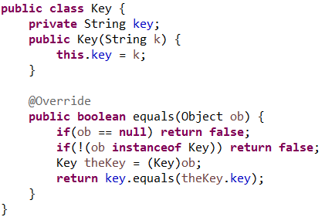

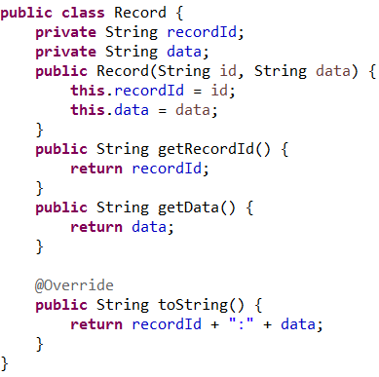
001:data
  - true
null

  - false
001:data
  - false
null

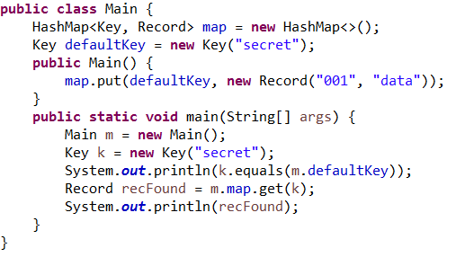
Part II. Short Answer

- [3 points] What is the output when the main method of Test class is run? (You may safely assume that no compiler errors will occur.)
class Test {
public static void test() throws Exception {
try {
throw new Exception("Exception thrown");
}
catch (Exception x){
System.out.println(x.getMessage());
}
finally {
System.out.println("In finally block!");
}
System.out.println("In test method");
}

public static void main(String[] args){
try{
test();
}
catch(Exception x){
System.out.println(x.getMessage());
}
}
}

- [5 points] Many data structures are implemented using the composition pattern, relying on some kind of background data structure to perform its operations. Below, several such data structures are listed (a – e). Match the data structure to the type of structure most often used as its background data structure (choose from 1 – 5).
Note. It is possible to use data structures in the right column more than once.

__ a. Binary Search Tree 1. Node
__b. HashMap 2. Entry
__ c. TreeSet (from Java library) 3. Binary Search Tree
__ d. LinkedList 4. Linked List
__ e. HashSet 5. HashMap

- [4 points] Below is code for a Circle class. The constructor accepts input for the size of the circle's radius and intends to validate that the input value for the radius is non-negative. To validate the input, the method validateRadius is called. Write the code for the validateRadius method. This method should throw an IllegalClosedCurveException if the input value of the radius is a negative number. Hint. You may need to modify the declaration of the method.
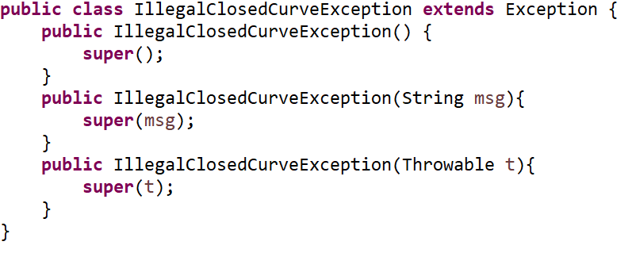

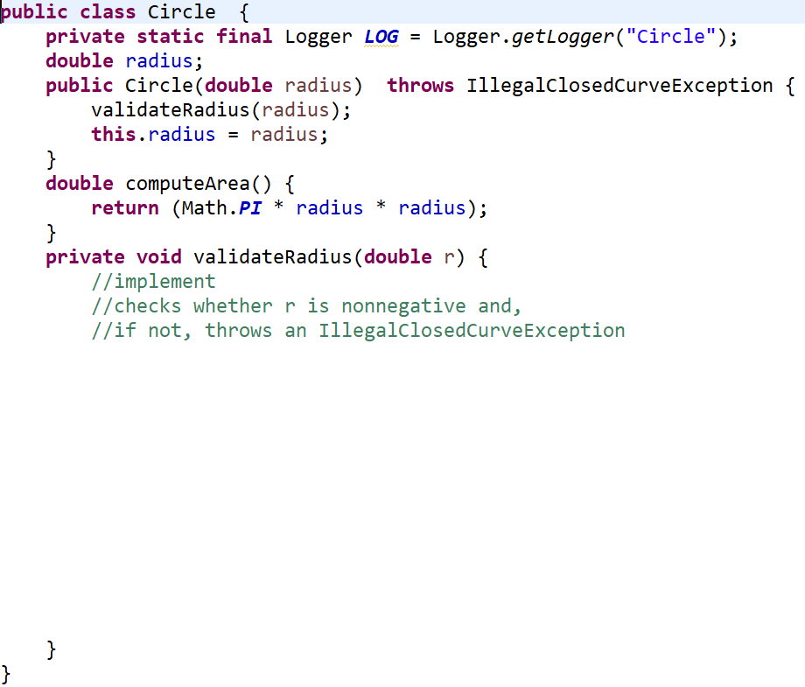

- [4 points] Draw the binary search tree obtained from successively adding the following integers to an initially empty BST: 5, 9, 2, 3, 1, 4, 8, 7

Part III. Programming Questions.

- (12 points) Below is a skeleton of a Stack implementation based on Nodes. The NodeStack class has a member inner class Node that has already been implemented, and has an instance variable topNode. Your task is to implement the three unimplemented stack methods shown in the code below. To implement pop, you must replace topNode with the next Node in the stack, and return the value contained in the original topNode. For peek, you must return the value stored in topNode, but you will not remove it. And for push, you will create a new Node and set it as the new topNode. All changes made by push, pop, and peek must ensure that links from Node to Node have been defined properly. Write your code in the space provided, below:

public class NodeStack {
private Node topNode = null;
public void push(String val) {

}

public String peek() {

}

public String pop() {

}

class Node {
private String data;
private Node next;
Node(String data, Node next) {
this.data = data;
this.next = next;
}
}

}

- (12 points) Fully implement the methods in the SearchForString class, shown below. The class SearchForString has one instance variable String[] arr, one constructor with signature

SearchForString (String[] arr)

and one instance method
public boolean search(String s)
The constructor should set its value in the instance variable of the class. The method search should be a recursive implementation of a search for the input argument s in the array arr; if s is found, the method should return true; false otherwise.
The method must implement the following recursive strategy:

Compare s to arr[len-1] (where len is the length of arr). If they are equal, return true. Otherwise, (recursively) search for s in the rest of the array.

You may safely assume that arr contains only non-null Strings and that the argument s passed in to search is never null. You must not assume that the Strings in arr are in sorted order.

To complete the problem, complete the work in the class SearchForString that has already been partially coded. A private instance method recurSearch, having two arguments (s and an integer argument upperIndex) has been included in SearchForString; you must make use of this method to do the actual recursion.

//write your code on the next page

public class SearchForString {
private String[] arr;
public SearchForString(String[] arr) {
this.arr = arr;
}

public boolean search(String s){

}
private boolean recurSearch(String s, int upperIndex){

}
}

Part IV. SCI (3 points)

Describe a parallel between principles of SCI and principles of computer science that have been discussed in the course. Richer content will be awarded more credit.

